📊 Key KPIs for Pizza Sales Analysis (with SQL Queries)

1. 🧾 Total Revenue
Definition: Total money earned from all orders
Formula: SUM(total_price)
SELECT
round(SUM(total_price),2) AS total_revenue
FROM pizza_sales;
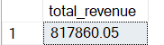

2. 💰 Average Order Value (AOV)
Definition: Average revenue generated per order
Formula: SUM(total_price) / COUNT(DISTINCT order_id)
SELECT
ROUND(SUM(total_price) * 1.0 / COUNT(DISTINCT order_id), 2) AS avg_order_value
FROM pizza_sales;

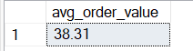

3. 🍕 Total Pizzas Sold
Definition: Total number of pizza units sold
Formula: SUM(quantity)
SELECT
SUM(quantity) AS total_pizzas_sold
FROM pizza_sales;

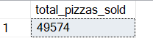

4. 🏆 Best-Selling Pizzas(Top 5)
Definition: Pizzas with the highest quantity sold
Formula: SUM(quantity) grouped by pizza_name
SELECT TOP 5
pizza_name,
SUM(quantity) AS total_sold
FROM pizza_sales
GROUP BY pizza_name
ORDER BY total_sold DESC;

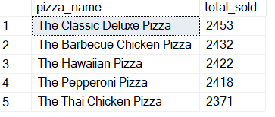

❌ Worst-Selling Pizzas(Bottom 5)
Definition: Pizzas with the lowest quantity sold
SELECT TOP 5
pizza_name,
SUM(quantity) AS total_sold
FROM pizza_sales
GROUP BY pizza_name
ORDER BY total_sold ASC;
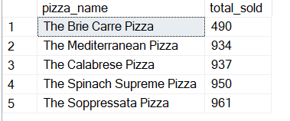

6. ⏰ Peak Order Hour(TOP 5) (By Revenue)
Definition: The hour of the day when most sales occur
Formula: Group by HOUR(order_time)
SELECT TOP 5
DATEPART(HOUR, order_time) AS order_hour,
round(SUM(total_price),2) AS hourly_revenue
FROM pizza_sales
GROUP BY DATEPART(HOUR, order_time)
ORDER BY hourly_revenue DESC;
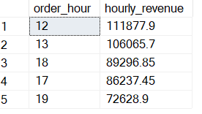

7. 📅 Highest Grossing Day of the Week
Definition: A Day with the highest total revenue
Formula: Group by weekday name
SELECT
DATENAME(WEEKDAY, CAST(order_date AS DATE)) AS day_name,
round(SUM(total_price),2) AS daily_revenue
FROM pizza_sales
GROUP BY DATENAME(WEEKDAY, CAST(order_date AS DATE))
ORDER BY daily_revenue DESC;

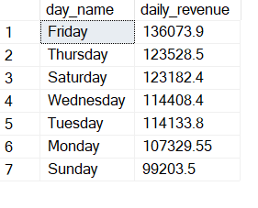

8. 📐 Revenue by Pizza Size
Definition: Total revenue earned by each pizza size
SELECT
pizza_size,
round(SUM(total_price),2) AS revenue
FROM pizza_sales
GROUP BY pizza_size
ORDER BY revenue DESC;

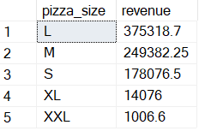

9. 🥦 Revenue by Pizza Category
Definition: Revenue earned by Classic, Veggie, Supreme, and Chicken
SELECT
pizza_category,
SUM(total_price) AS revenue
FROM pizza_sales
GROUP BY pizza_category
ORDER BY revenue DESC;
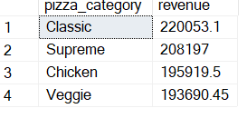

10. 🪑 Estimated Seat Utilisation Rate
Customer Estimation Logic
We analysed 21,350 unique orders and 48,620 pizza line items. On average, each order consists of 2.28 pizza items.
Therefore, we estimate customer count based on the number of order_details_id, assuming each pizza item represents one person (≈ 1 pizza per person).
This results in an estimated 48,620 customers served over the year.
SELECT
ROUND(CAST(48620 AS FLOAT)/60, 2) AS total_full_seat_cycles,
ROUND(CAST(48620 AS FLOAT) / 60 / 365, 2) AS avg_full_seat_cycles_per_day,
ROUND(CAST(48620 AS FLOAT) / (365 * 60) * 100, 2) AS avg_daily_seat_utilization_percent
Seating Utilisation Insight:
Over the years, Plato’s Pizza served approximately 48,620 customers.
Given 60 seats and 365 days, this equates to a daily average seating utilisation of 222%, meaning each seat is used 2.2 times daily.
This reflects a healthy table turnover, especially during peak hours.
Initially, we used order_details_id as a proxy for customer count, assuming each unique pizza configuration was intended for a separate person.
However, for more accurate seating capacity analysis, we use SUM(quantity) to represent estimated customers, under the assumption that 1 pizza ≈ 1 customer. This provides a closer match to real-world dine-in behavior and accounts for actual volume of items served.
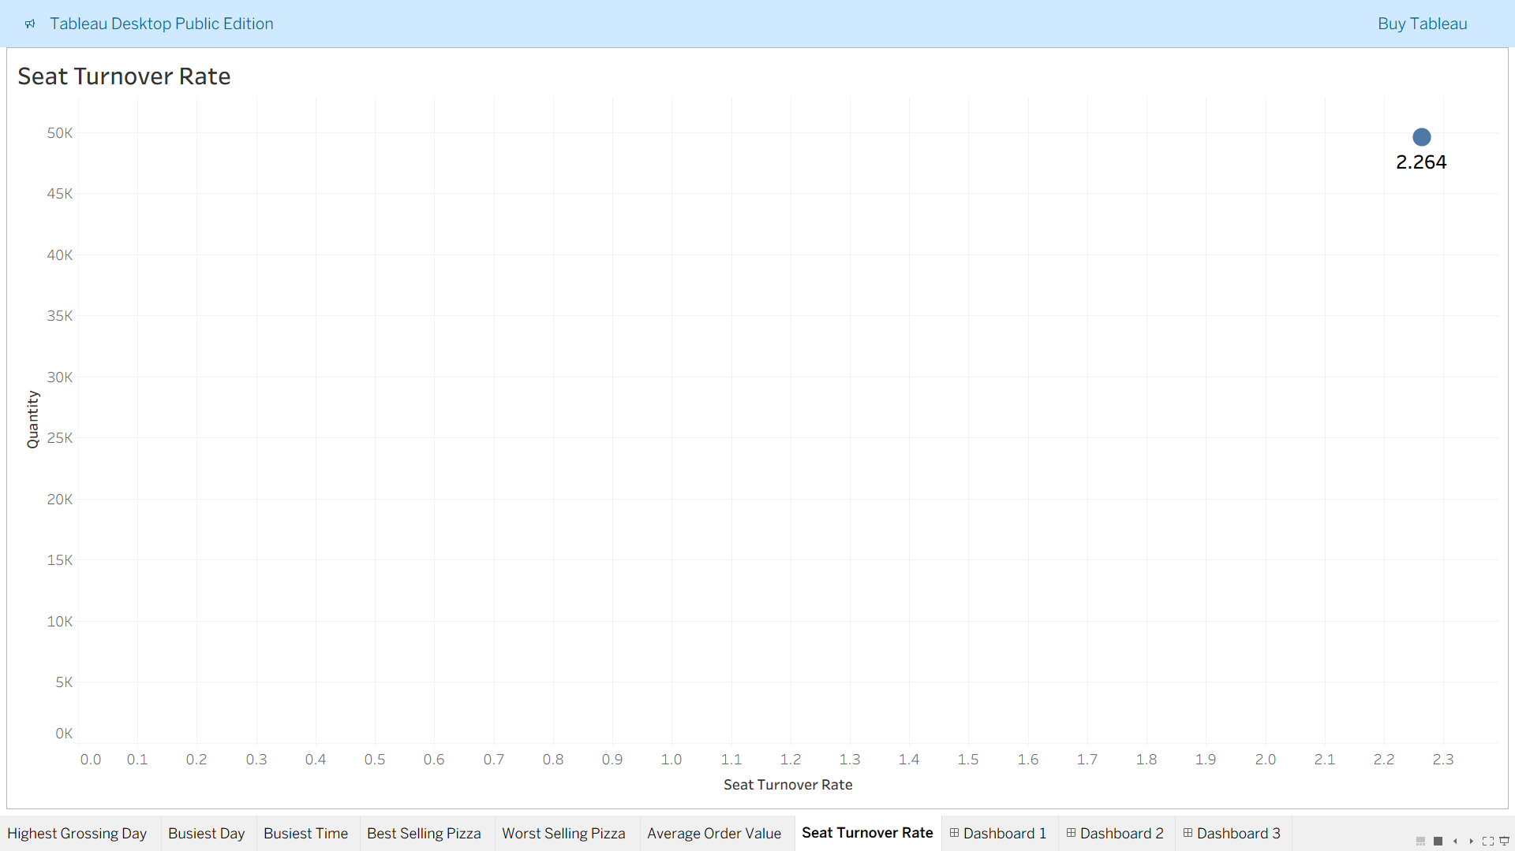
This makes Seat Turnover Rate 2.264 times per day.
Note:- We can make the assumption that 1 table is occupied by 4 seats.
11. Busiest Day of the Year
As seen in Tableau Chart Busiest Day is Friday
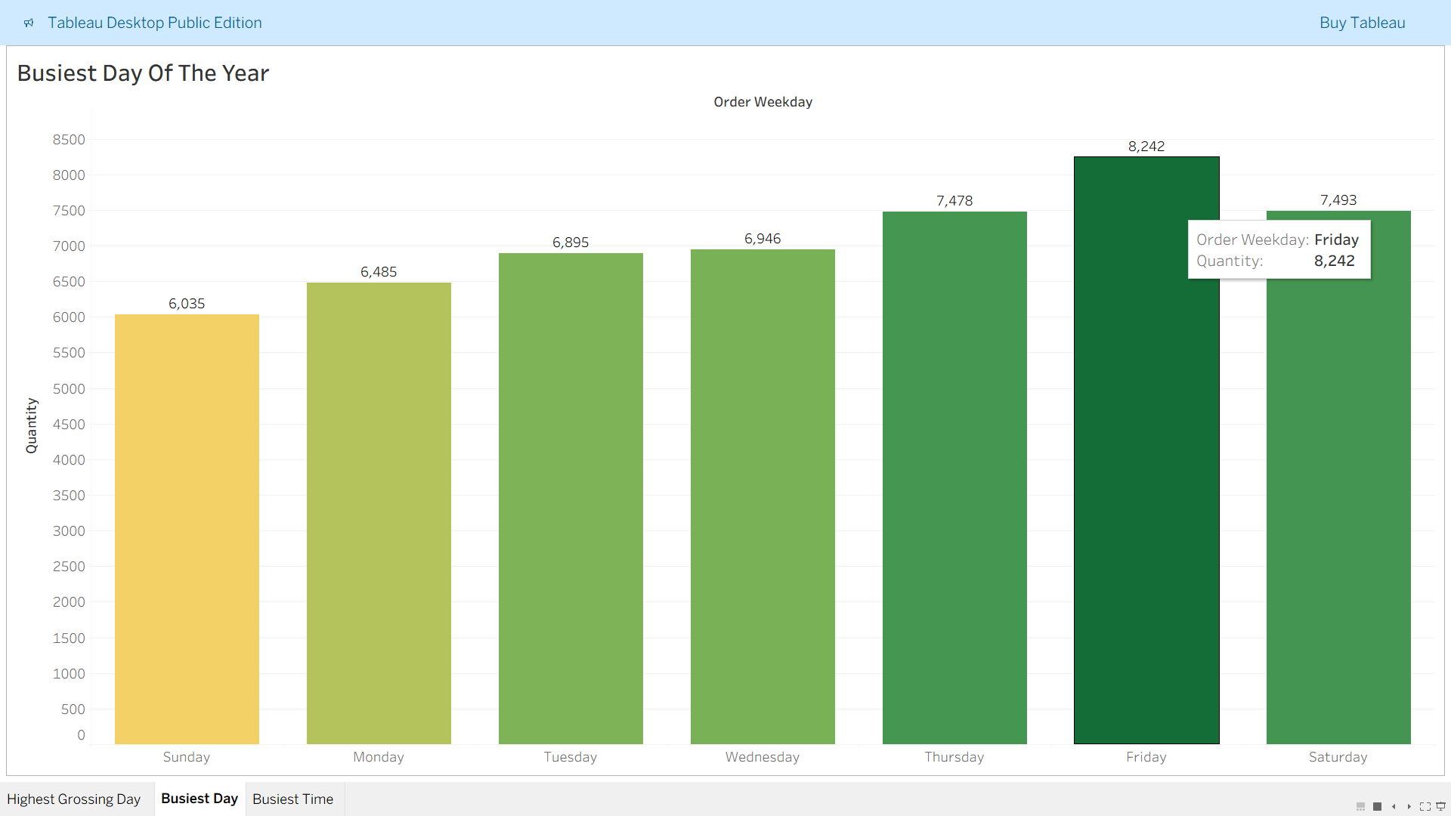
During this day, the highest of 8242 pizzas are made in a year.
12. Busiest Time of the Year
As seen in Tableau Chart Busiest Time is 12:00 PM.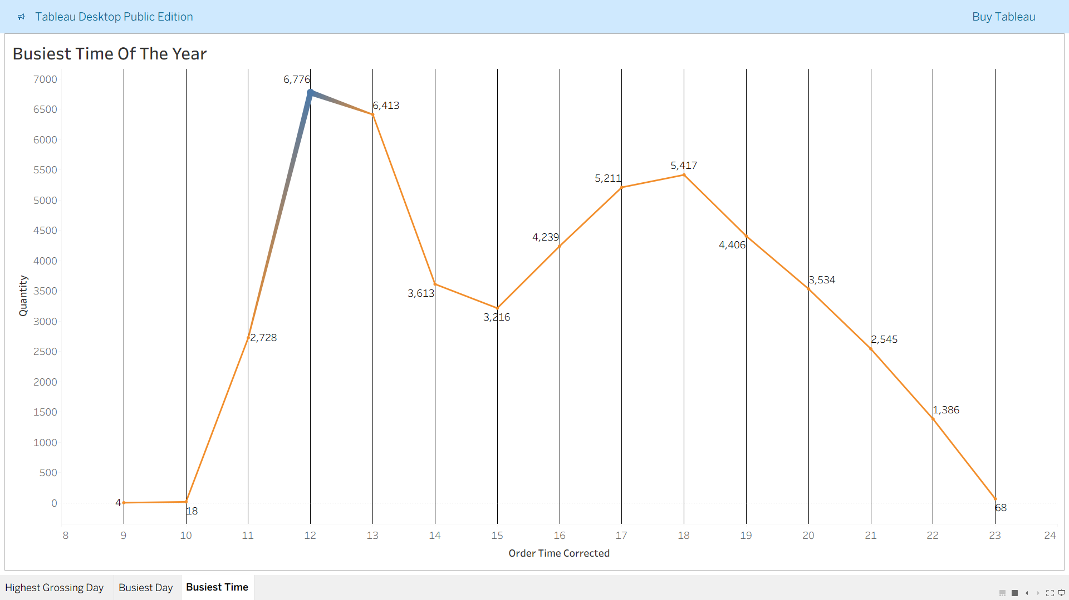
During this time, the highest of 6776 pizzas are made in a year.
Pizzas made at 12 PM on Fridays only, using SQL
SELECT SUM(quantity) AS pizzas_at_noon_on_friday
FROM pizza_data.dbo.pizza_sales
WHERE DATEPART(HOUR, order_time) = 12
AND DATENAME(WEEKDAY, order_date) = 'Friday';
